Pre-requisites

Eclipse Helios JEE development

Apache Tomcat 7.0.33 or higher

Apache CXF 2.7.0 or higher

Open up Eclipse

Create a new Dynamic Web Project (File -> New -> Dynamic Web Project)

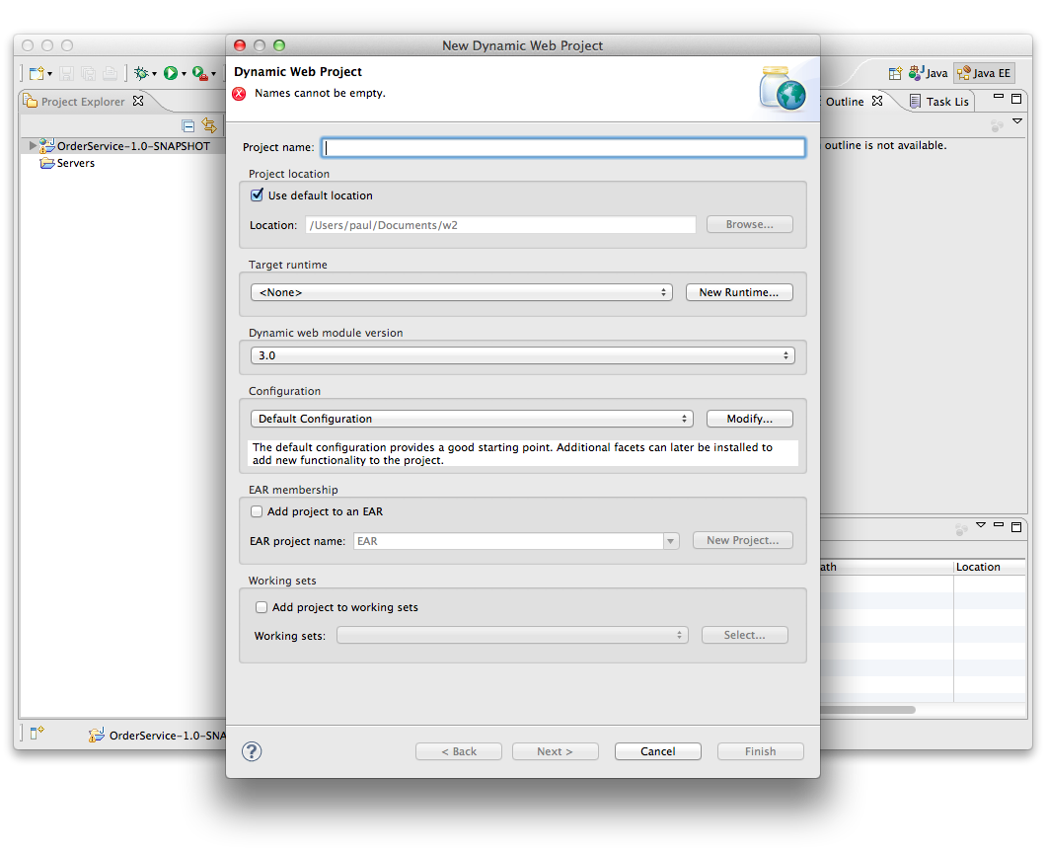

Now click New Runtime and choose Tomcat 7.0

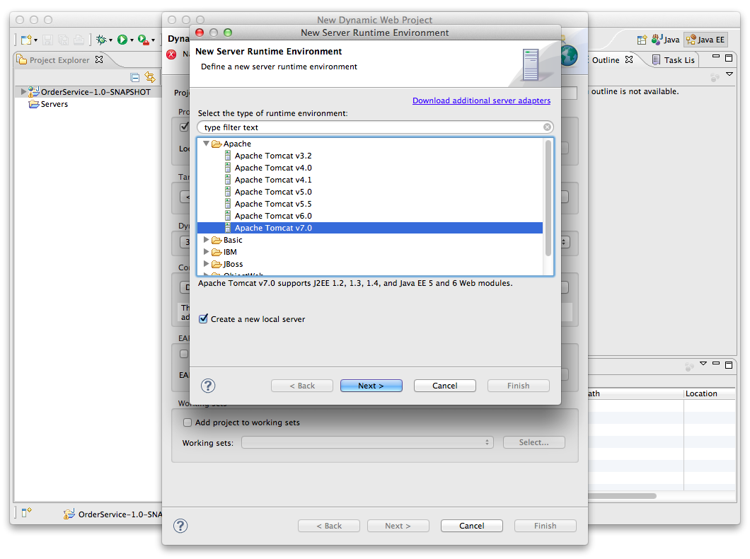

Click Next

Browse to the directory where you have Apache Tomcat installed and select that

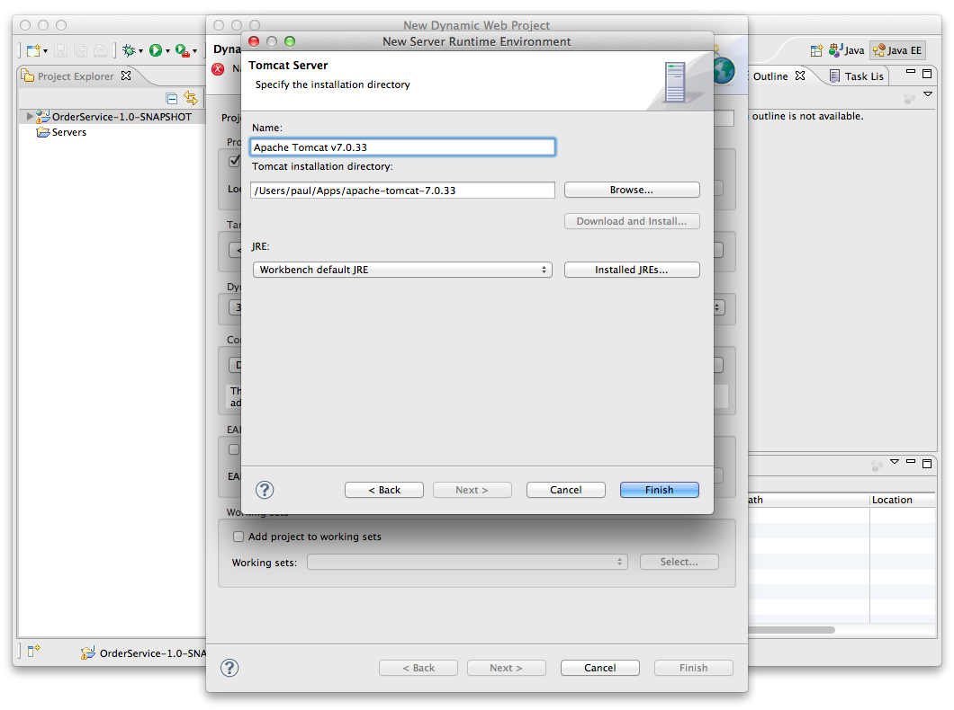

Now we need to modify the Tomcat config. Click on Modify next to Default Tomcat Configuration

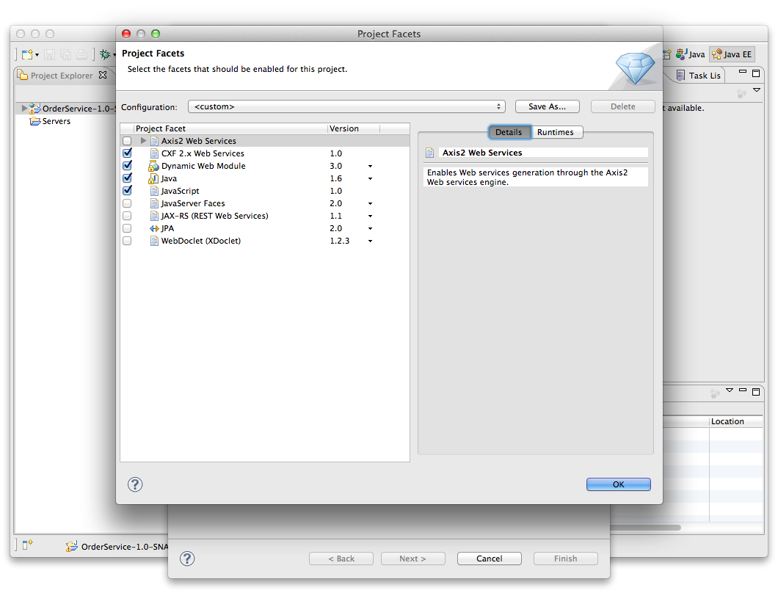

Enable the CXF 2.x Web Services section.

Now you should be back in the initial Dialog, so give the project a name, e.g. JAXWSSample

Click Next, Next, Next until you are at the CXF Facet configuration dialog

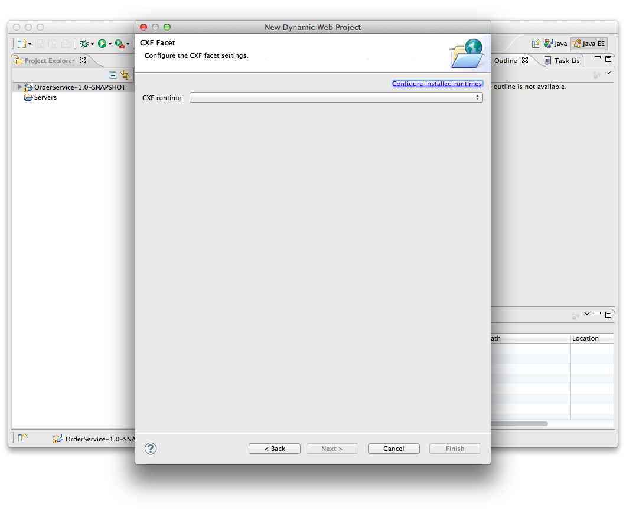Click Configure Installed Runtimes

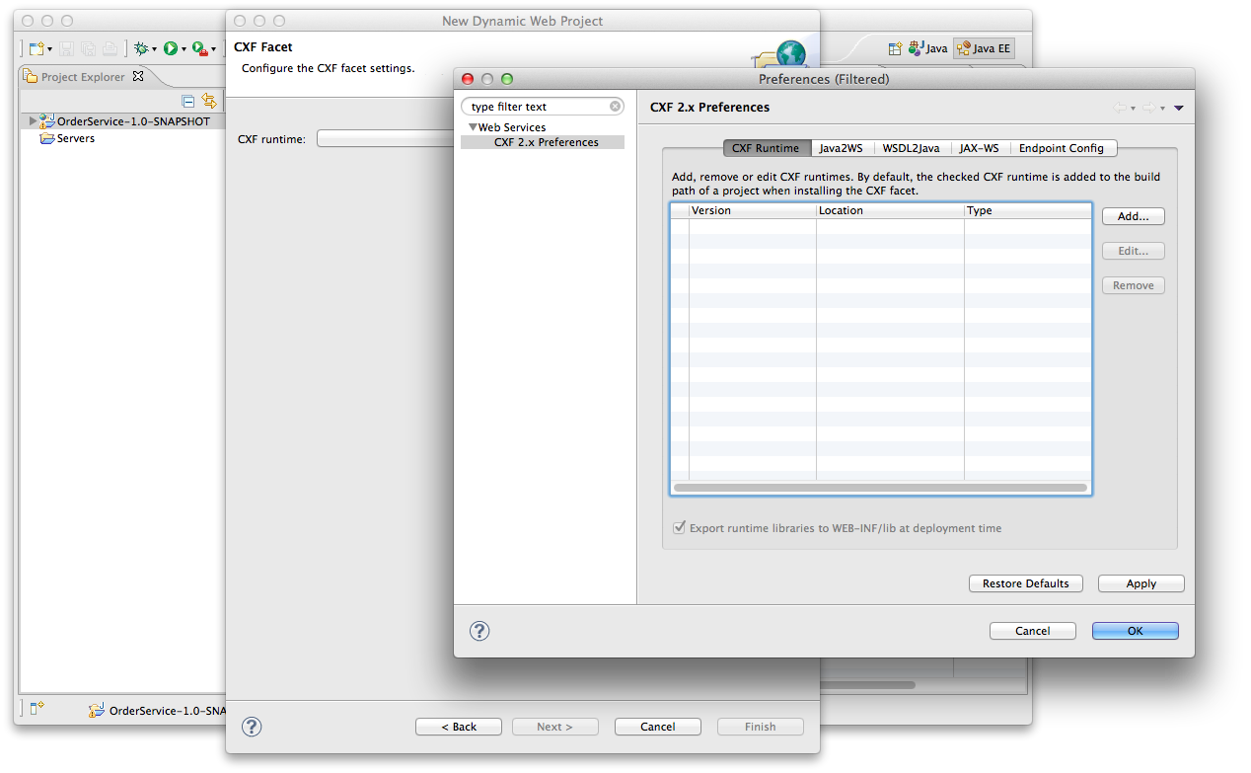

Now click Add

Browse to the CXF install directory.

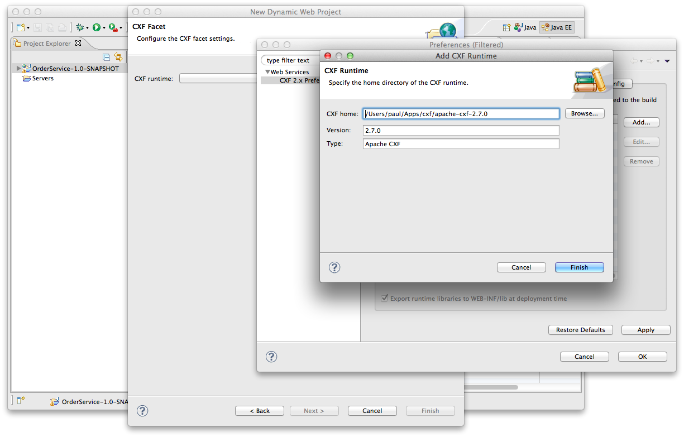

Now click Finish

Now select the tick box next to the CXF 2.7.0 version. Click Finish and Finish again.

You should now have a project.

Import the following four files into the project

freo.me.jaxws.Order

freo.me.jaxws.OrderService

freo.me.jaxws.OrderServiceImpl

freo.me.jaxws.NotFoundException

From the following file

<https://raw.github.com/pzfreo/ox-soa/master/lab-exercises/source/jaxws-service-code.zip>

You can get the file using curl:

curl https://raw.github.com/pzfreo/ox-soa/master/lab-exercises/source/jaxws-service-code.zip -o jaxws-service-code.zip

Take a good look at the code and understand it.

Now we can expose this code as a Web Service using the JAXWS wizard built into Eclipse. Select the OrderService class and Right-Click on it. Now Select Web Services. Now Create Web Service.

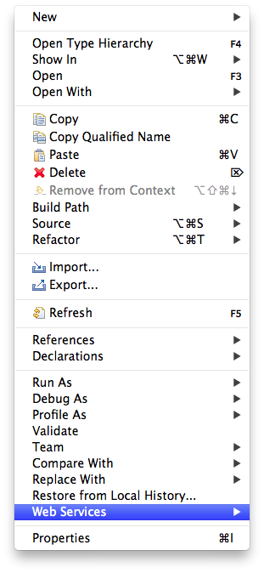

You will see the following dialog:

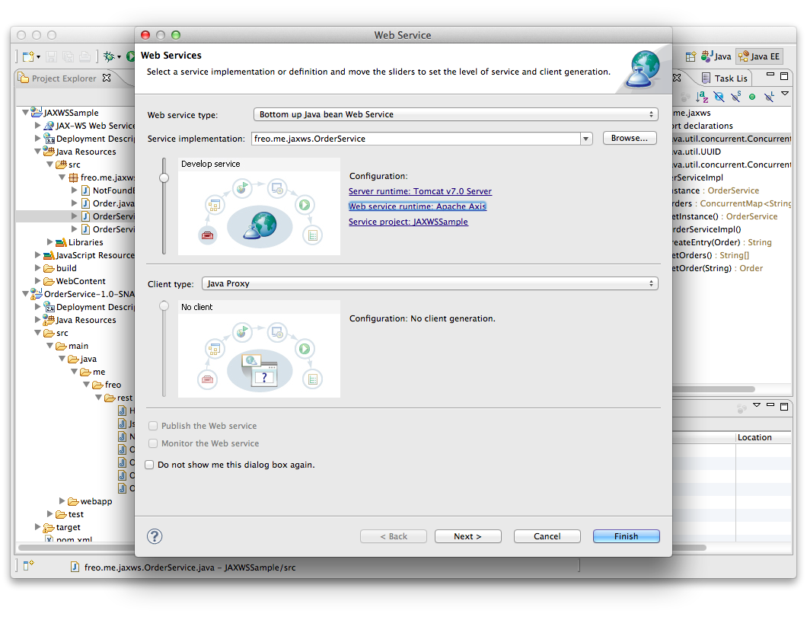

Now Click on the Web Service Runtime and change it to Apache CXF v2.x

Click Next

Choose freo.me.jaxws.OrderServiceImpl as the Service Implementation.

Click Next

You will see a screen like this:

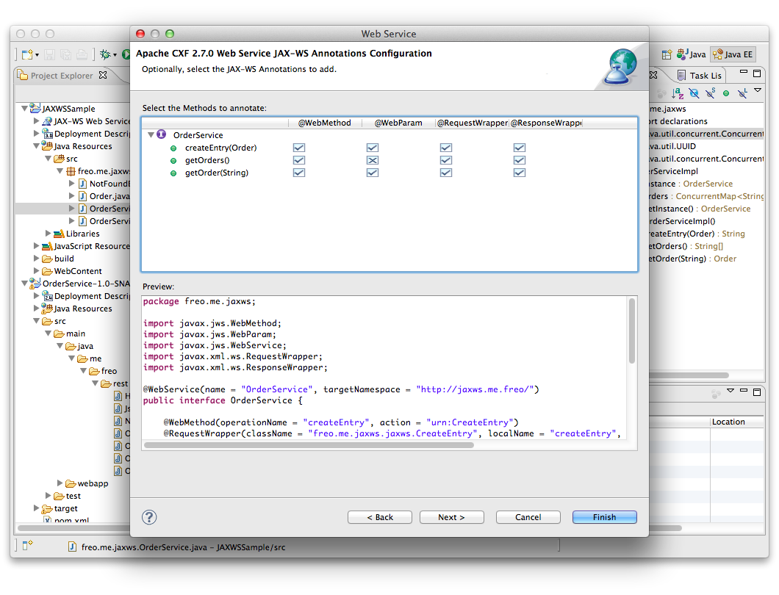

Keep everything the same and click Next.

You should see:

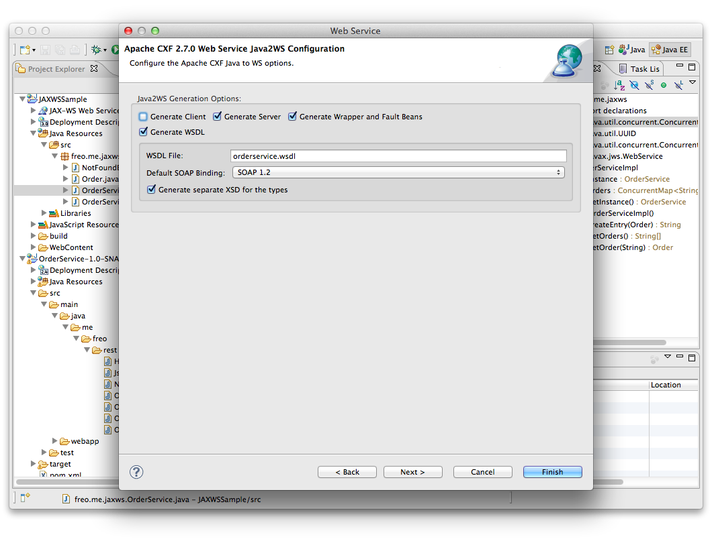

Now make sure Generate Server is clicked.

Click Next.

Do not select either UDDI option:

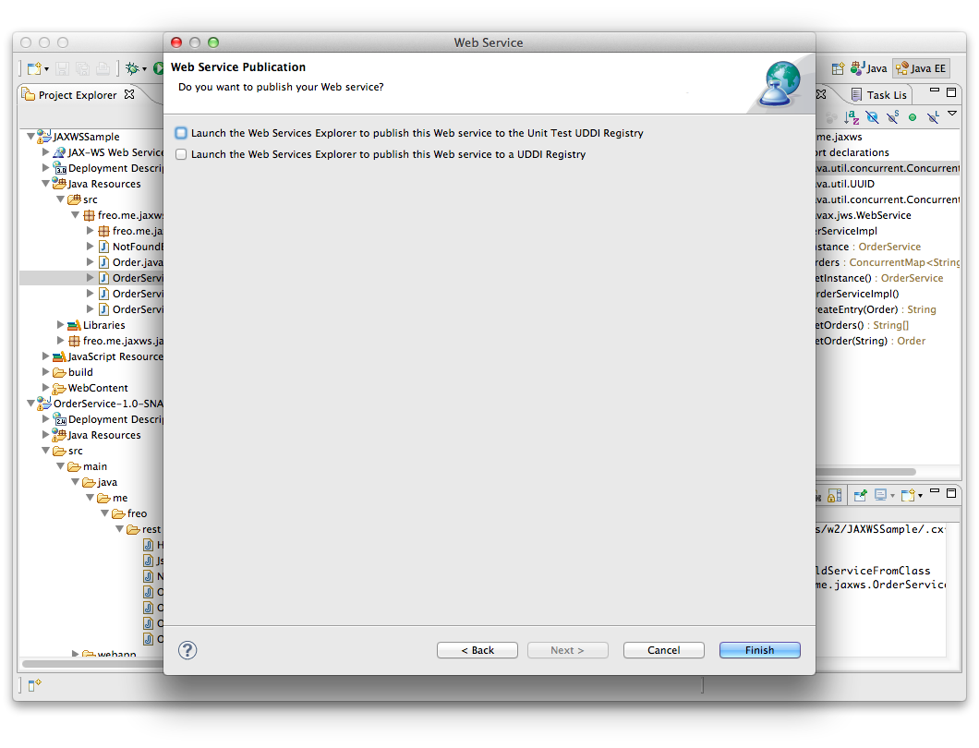

Click Finish

This will generate a number of additional classes.

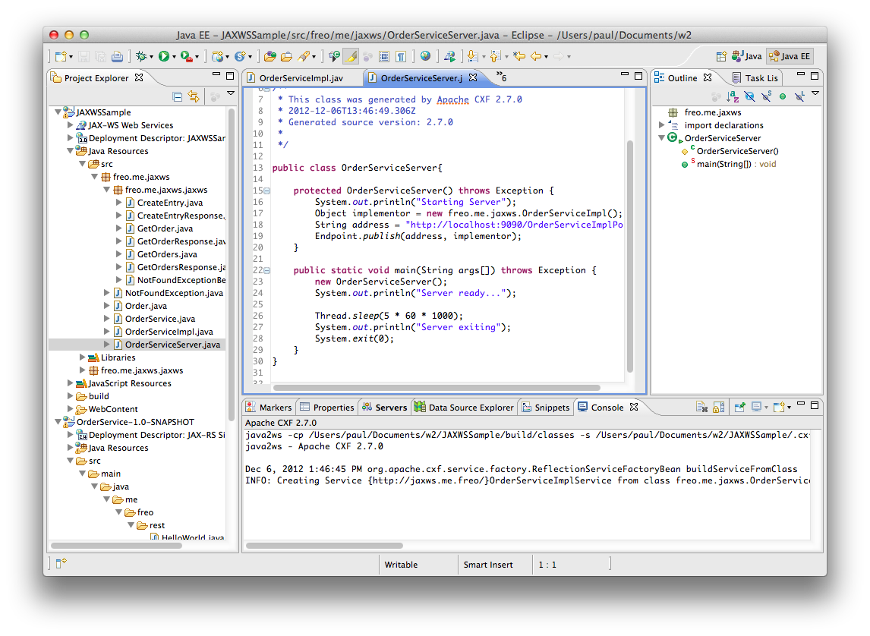

Firstly, it will create a set of classes to map XML types.

Secondly it will create a set of annotations in your existing code. Finally it will create a Server class that can be used to run the service standalone.

You can now run this in one of two ways: